**Bank database**

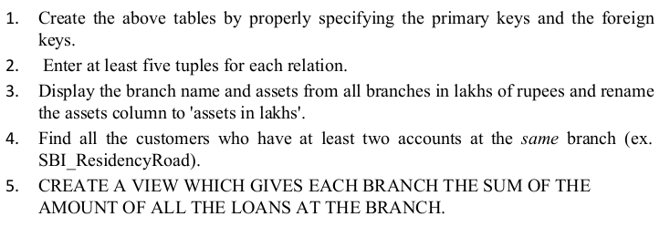

**Creating table**

create table branch(branch_name varchar(30),branch_city varchar(25),assets real,primary key (branch_name));

create table bankaccount(accno int,branch_name varchar(30),balance real,primary key(accno),foreign key(branch_name) references branch(branch_name));

create table bankcustomer(customername varchar(20),customer_street varchar(30),customer_city varchar(35),primary key(customername));

create table bankcustomer(customername varchar(20),customer_street varchar(30),customer_city varchar(35),primary key(customername));

create table loan(loan_number int,branch_name varchar(30),amount real,primary key(loan_number),foreign key(branch_name) references branch(branch_name));

**Inserting values**

insert into branch values("SBI_Chamrajpet","Bangalore",50000);

insert into branch values("SBI_ResidencyRoad","Bangalore",10000);

insert into branch values("SBI_ShivajiRoad","Bombay",20000);

insert into branch values("SBI_Parliamentroad","Delhi",10000);

insert into branch values("SBI_Jantarmantar","Delhi",20000);

select * from branch;

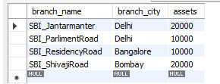

insert into bankaccount values(1,"SBI_Chamrajpet",2000);

insert into bankaccount values(2,"SBI_ResidencyRoad",5000);

insert into bankaccount values(3,"SBI_ShivajiRoad",6000);

insert into bankaccount values(4,"SBI_Parliamentroad",9000);

insert into bankaccount values(5,"SBI_Jantarmantar",8000);

insert into bankaccount values(6,"SBI_ShivajiRoad",4000);

insert into bankaccount values(8,"SBI_ResidencyRoad",4000);

insert into bankaccount values(9,"SBI_Parliamentroad",3000);

insert into bankaccount values(10,"SBI_ResidencyRoad",5000);

insert into bankaccount values(11,"SBI_Jantarmantar",2000);

select * from bankaccount;

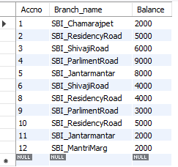

insert into bankcustomer values("Avinash","BUll_temple_Road","Bangalore");

insert into bankcustomer values("Dinesh","Bannergatta_Road","Bangalore");

insert into bankcustomer values("Mohan","NationaCollege_Road","Bangalore");

insert into bankcustomer values("Nikil","Akbar_Road","Delhi");

insert into bankcustomer values("Ravi","Prithviraj_Road","Delhi");

select * from bankcustomer;

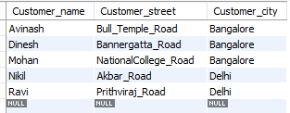

insert into depositer values("Avinash",1);

insert into depositer values("Dinesh",2);

insert into depositer values("Nikil",4);

insert into depositer values("Ravi",5);

insert into depositer values("Avinash",8);

insert into depositer values("Nikil",9);

insert into depositer values("Dinesh",10);

insert into depositer values("Nikil",11);

select * from depositer;

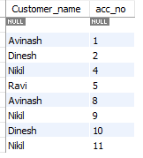

insert into loan values(1,"SBI_Chamrajpet",1000);

insert into loan values(2,"SBI_ResidencyRoad",2000);

insert into loan values(3,"SBI_ShivajiRoad",3000);

insert into loan values(4,"SBI_Parliamentroad",4000);

insert into loan values(5,"SBI_Jantarmantar",5000);

select * from loan;

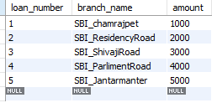

select branch_name,(assets/100000) as assets_in_lakhs from branch;

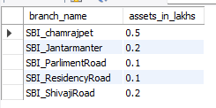

select d.customername from depositer d,bankaccount b where d.accno=b.accno group by d.customername having count(d.accno)>=2;

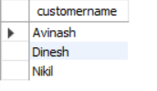

create view sum_of_loan1as select branch_name,sum(amount) from loangroup by branch_name;

select * from sum_of_loan1;

